6.Create A Cloud Software Application Hospital Reservation Using Any Cloud Service Provider To Demonstrate Software As A Service (Saas) .
AIM :
To create a cloud-based software application for hospital reservation system using a cloud service provider and demonstrate the Software as a Service (SaaS) model.
PROCEDURE
- A cloud service provider such as Zoho Creator is selected to develop the application.
- A new cloud application named Hospital Reservation System is created.
- Forms such as Doctor/Specialty Details, Patient Details, and Appointment Request are designed in the cloud platform.
- The application is hosted on the cloud and made accessible through a web browser.
- Doctor schedules, patient records, and appointment data are stored securely in the cloud database.
- Reports are generated to view available slots, appointment status, and patient lists.
- The application is tested to ensure proper functionality and cloud accessibility

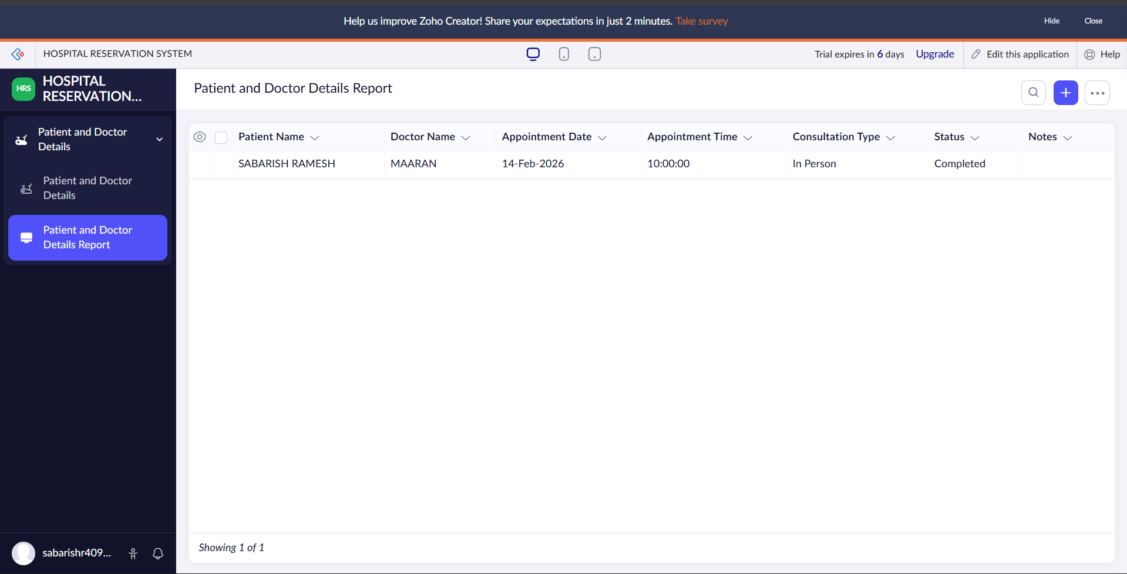
RESULT :

